**AWS Elastic Beanstalk**

AWS Elastic Beanstalk is a compute service that makes it easier for the developers to quickly deploy and manage applications that you upload to the AWS cloud. Developers simply upload their application to the AWS cloud, and then let the AWS Beanstalk provision and handle the configuration for you. Your application will be provided with capacity provisioning, load balancing, auto-scaling, and health monitoring.

LAB:

Go to the Elastic Beanstalk service and Click on Create Application

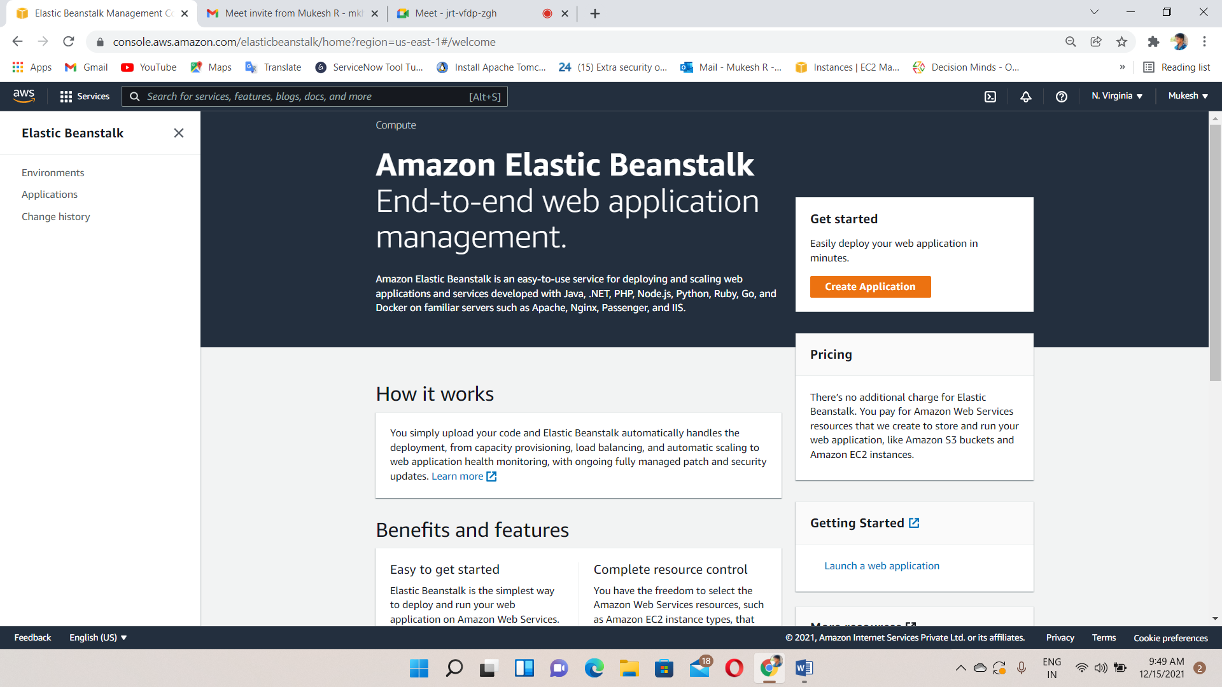

Give a name for Application

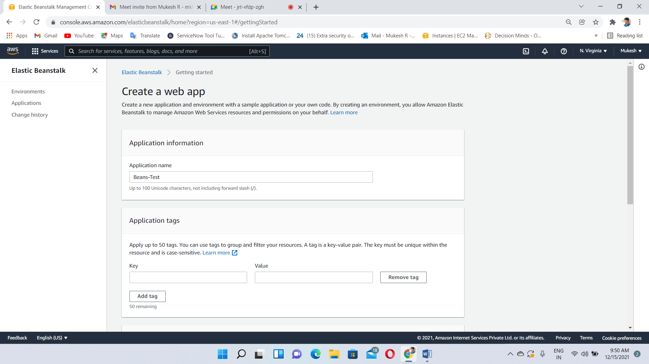

Choose Platform: Tomcat and it supports .Net,PHP,Java,Ruby etc…

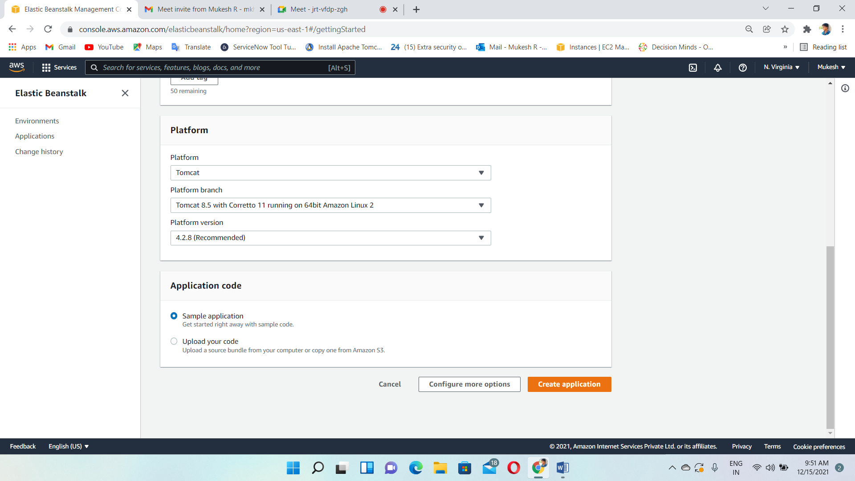

Creating application and Environment

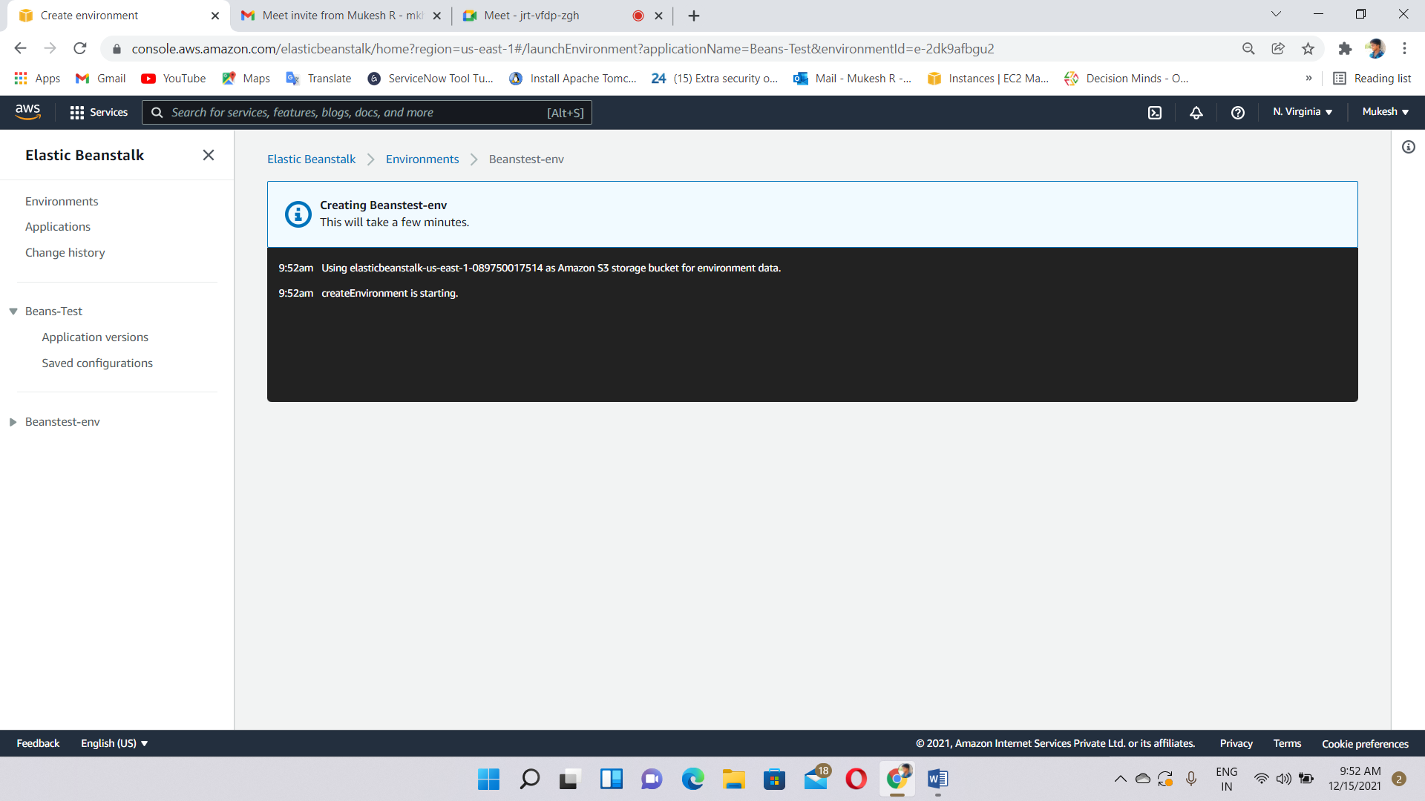

Environment application created and health status - ok

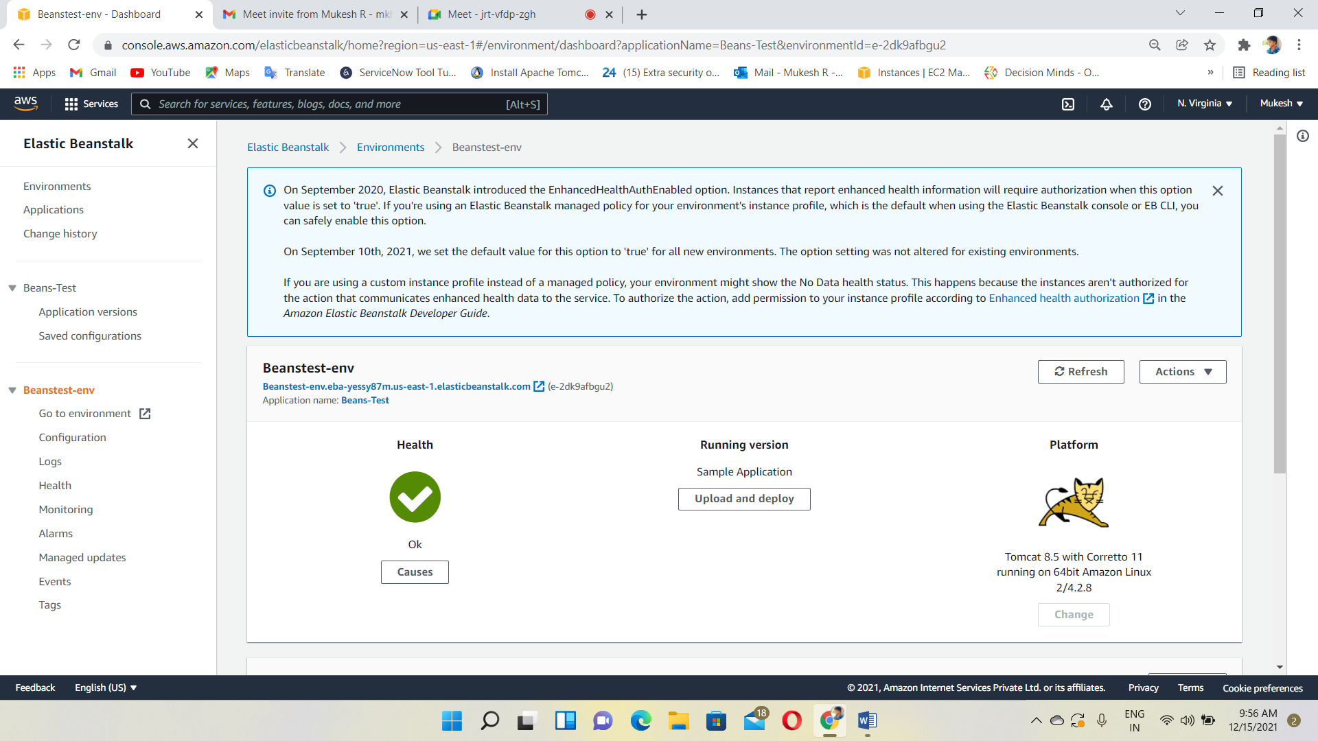

Copy & Paste the ELB URL on Browser and Tomcat application running

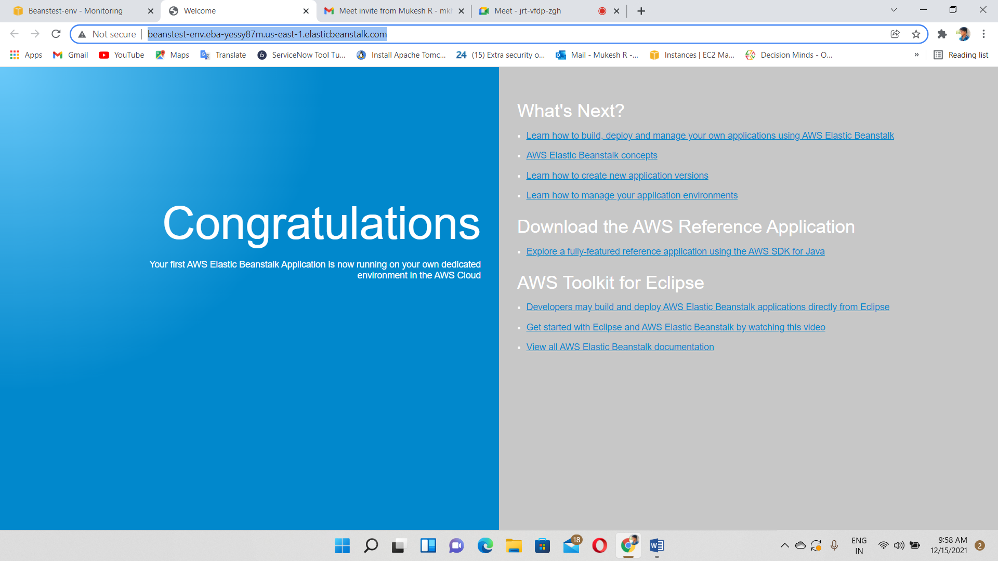

We can check and manage health, performance, logs, events using left bottom side navigation bar

